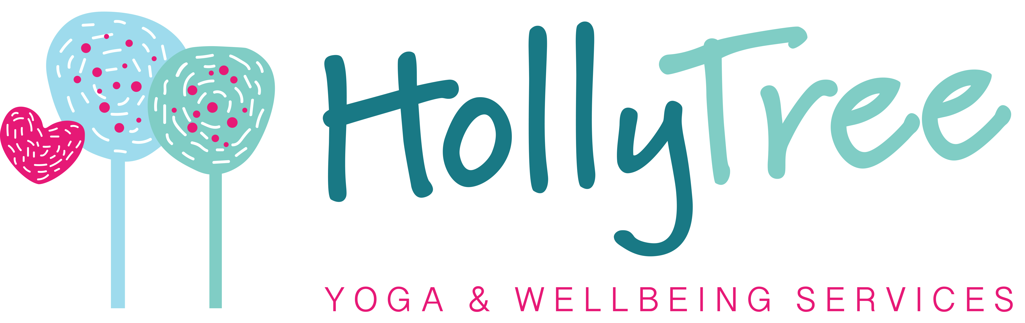

Social Media Policy

Policy brief & purpose
Our social media policy provides a framework for using social media. Social media is a place where people exchange information, opinions and experiences to learn, develop and have fun. Whether Directors of the organisation are handling the organisations account or use one of their own, they should remain productive. This policy provides practical advice to avoid issues that might arise by careless use of social media in the organisation.

Scope
We expect all our Directors, employees, and freelance Practitioners to follow this policy.

Policy elements
“Social media” refers to a variety of online communities like blogs, social networks, chat rooms and forums. This policy covers all of them.
We consider two different elements: using personal social media while working for Hollytree Yoga and Wellbeing services and representing our organisation through social media.

Using personal social media
We allow Directors, employees and freelance Practitioners to access their personal accounts during their hours worked for Hollytree Yoga and Wellbeing services. But, we expect them to act responsibly and ensure their productivity isn’t affected. Using social media excessively while working can reduce efficiency and concentration. Whether using accounts for business or personal purposes, it is easy to become sidetracked by the vast amount of available content.
We advise all members of our organisation to:
- Use their common sense. If Volunteers, Practitioners or Directors neglect their work duties to spend time on social media, their decline in productivity will show on their performance reviews.
- Ensure others know that personal account or statements don’t represent our organisation. Members shouldn’t state or imply that their personal opinions and content are authorised or endorsed by our organisation. We advise using a disclaimer such as “opinions are my own” to avoid misunderstandings.
- Avoid sharing intellectual property like trademarks on a personal account without approval. Confidentiality policies and laws always apply.
- Avoid any defamatory, offensive or derogatory content.

Representing Hollytree Yoga and Wellbeing services
Some members of the organisation represent the organisation by handling social media accounts or speaking on our organisations behalf. We expect them to act carefully and responsibly to protect our image and reputation. Everyone should:
- Be respectful, polite and patient, when engaging in conversations on the organisations behalf. They should be extra careful when making declarations or promises towards customers and funders.
- Avoid speaking on matters outside their field of expertise when possible. Everyone should be careful not to answer questions or make statements that fall under somebody else’s responsibility
- Follow our confidentiality policy and data protection policy and observe laws on copyright, trademarks, plagiarism and fair use
- Inform our Marketing Director Liz Boardman when they wish to share any major-impact content
- Avoid deleting or ignoring comments for no reason. They should listen and reply to criticism.
- Never post discriminatory, offensive or libelous content and commentary
- Correct or remove any misleading or false content as quickly as possible

Disciplinary Consequences
Liz Boardman will monitor all social media postings on our organisations account.
We may have to take disciplinary action leading up to and including termination of work projects or roles if someone does not follow this policy’s guidelines. Examples of non-conformity with the employee social media policy include but are not limited to:
- Disregarding role responsibilities and deadlines to use social media
- Disclosing confidential information through personal or the organisations account
- Directing offensive comments towards other members of the online community

